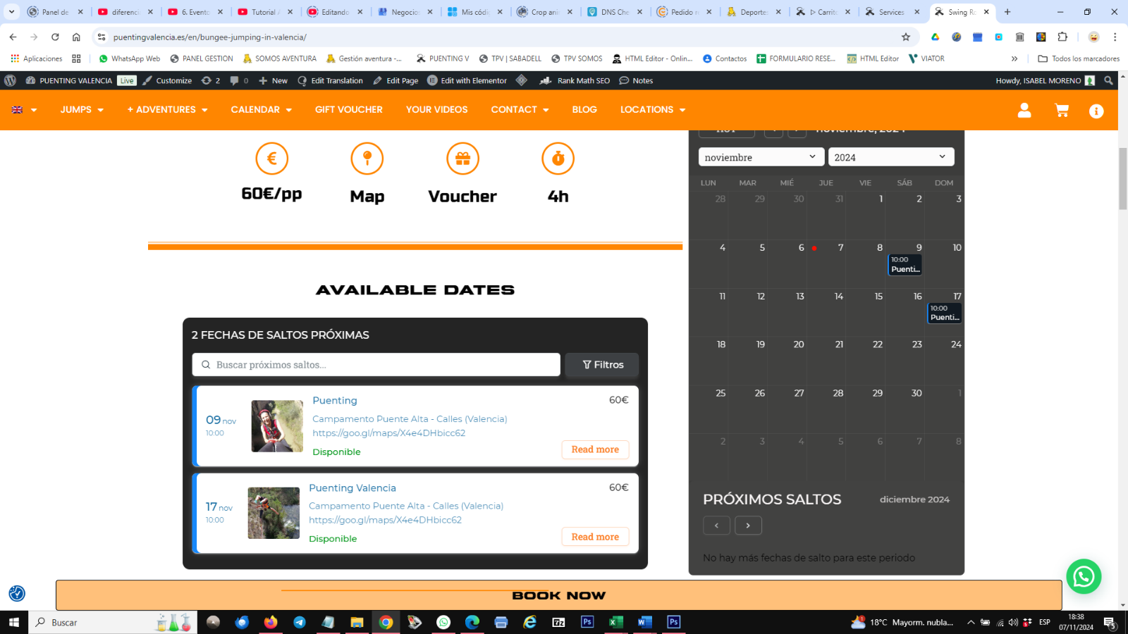All these samples are on the site English version. It shows Spanish labels, depending on browser, it shows more or less labels in the other language. On edge, week days and months appear in English, but most labels keep showing in Spanish.

2 FECHAS DE SALTO PROXIMAS

Filtros

Buscar próximos saltos…

Disponible

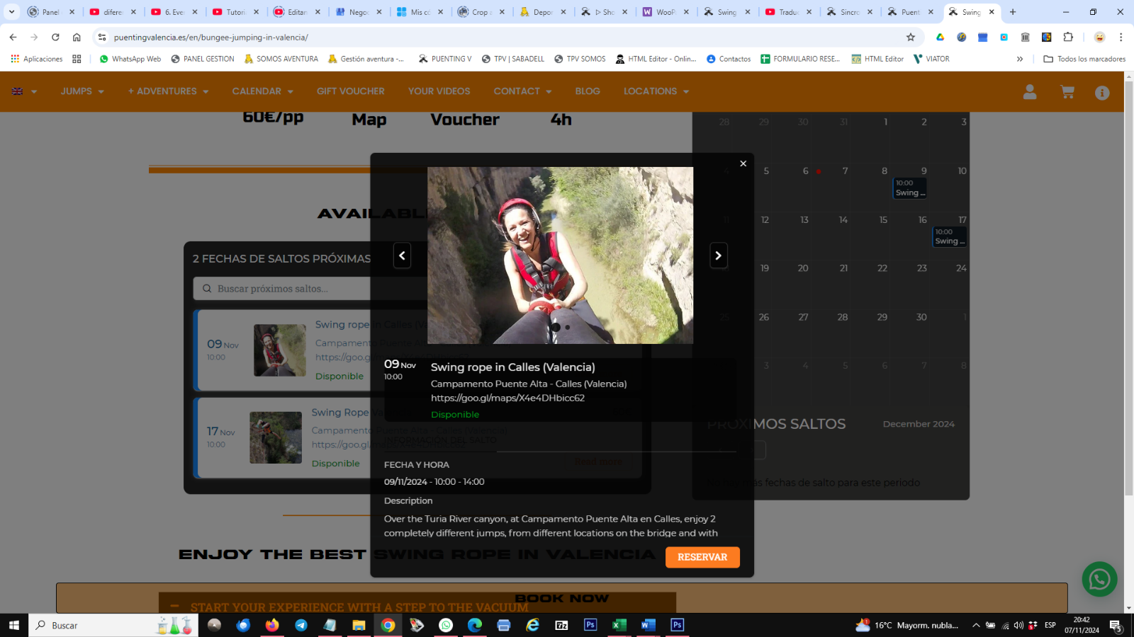

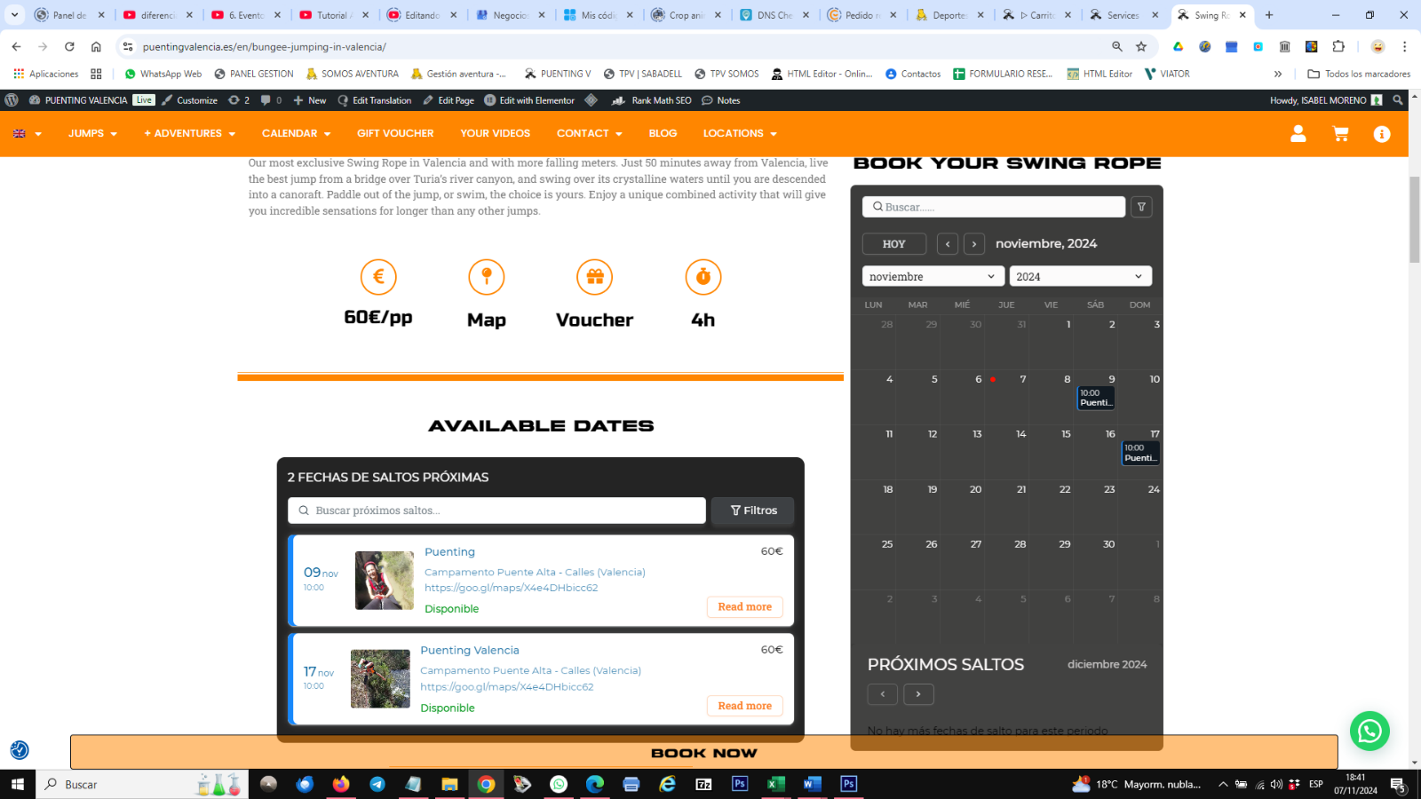 Buscar…

HOY

Noviembre 2024

LUN, MAR, MIE…

PRÓXIMOS SALTOS

Diciembre 2024

No hay más fechas para este periodo

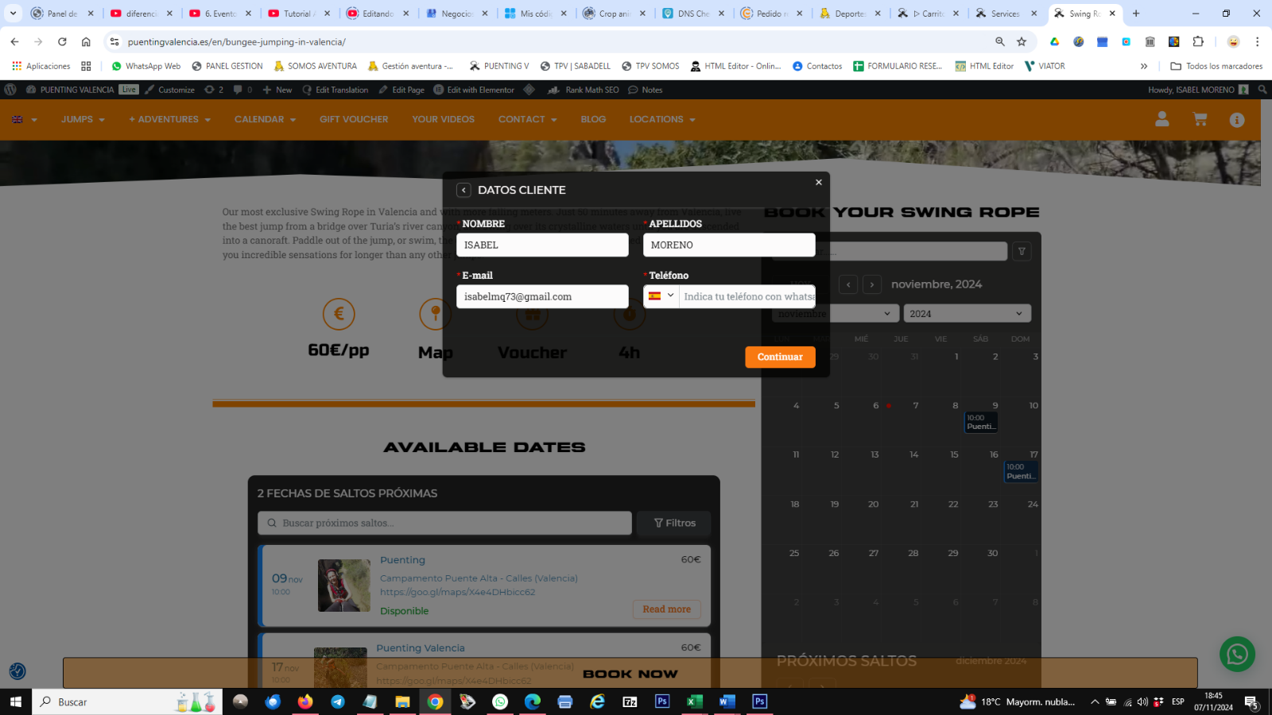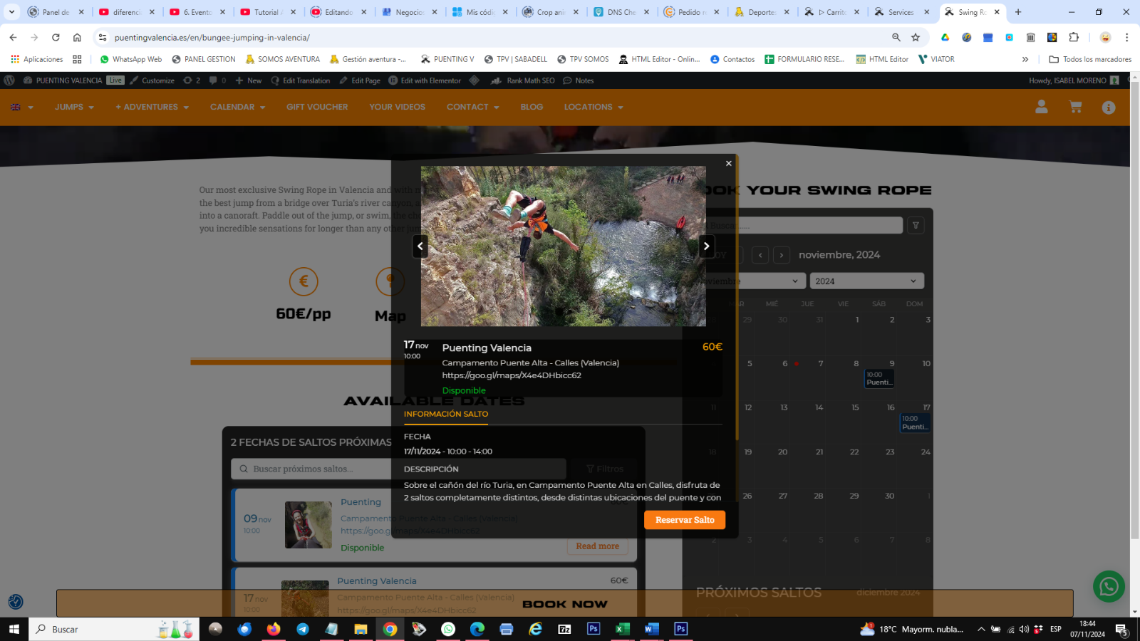 It didn’t translate any label even they are translated in Amelia

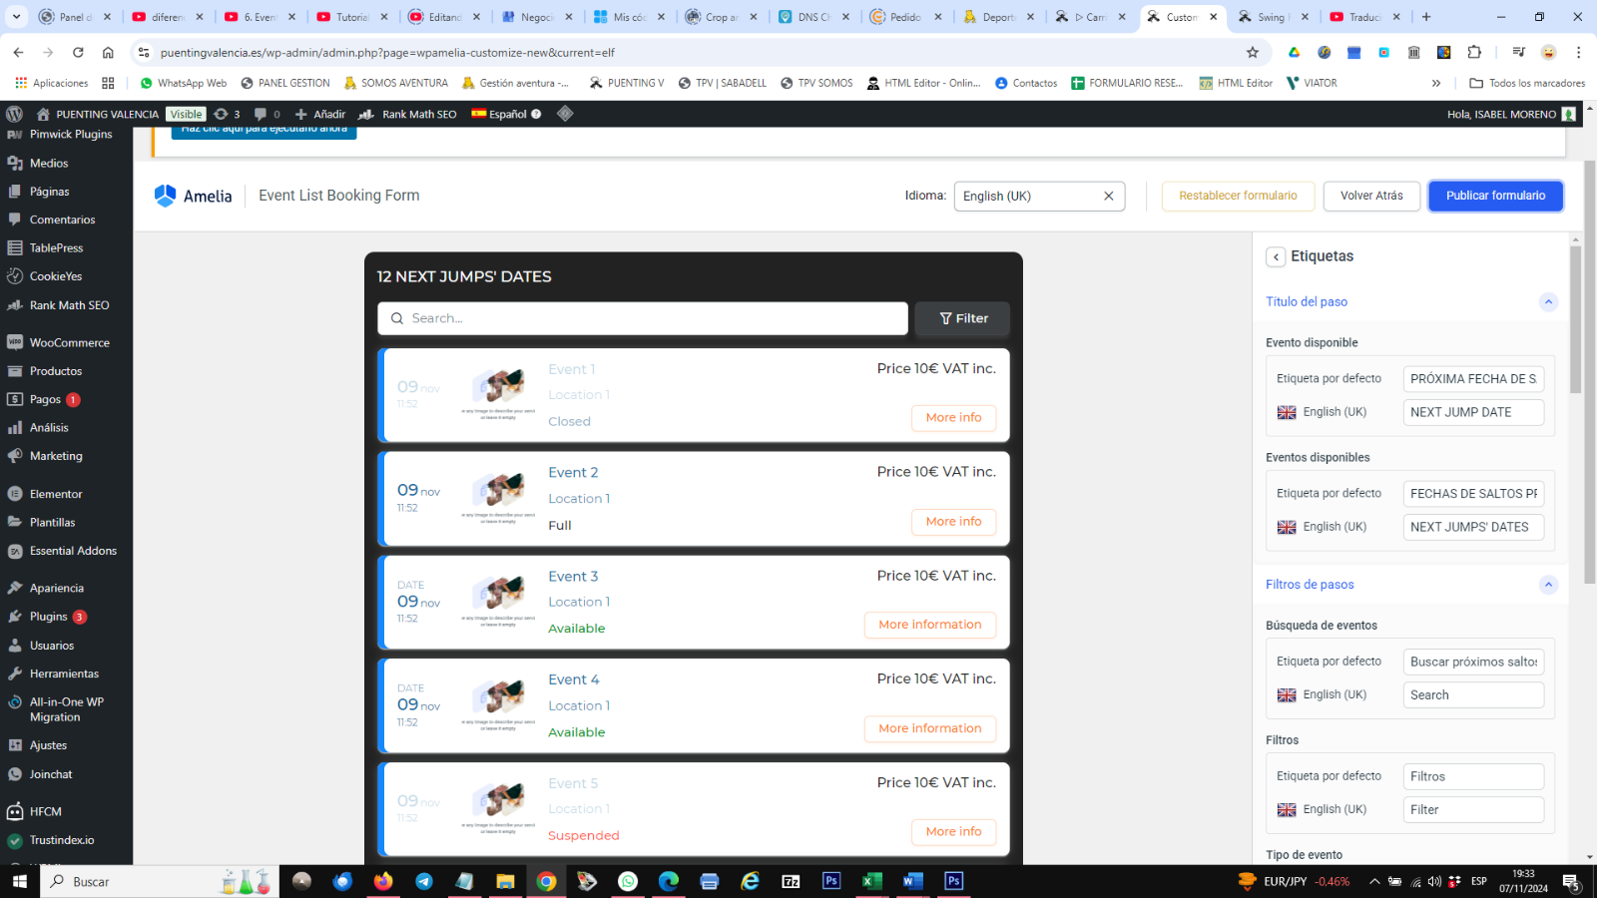

On woocommerce chart you can check that, in previous view while editing, it appears correctly, but in website, they turn to Spanish.

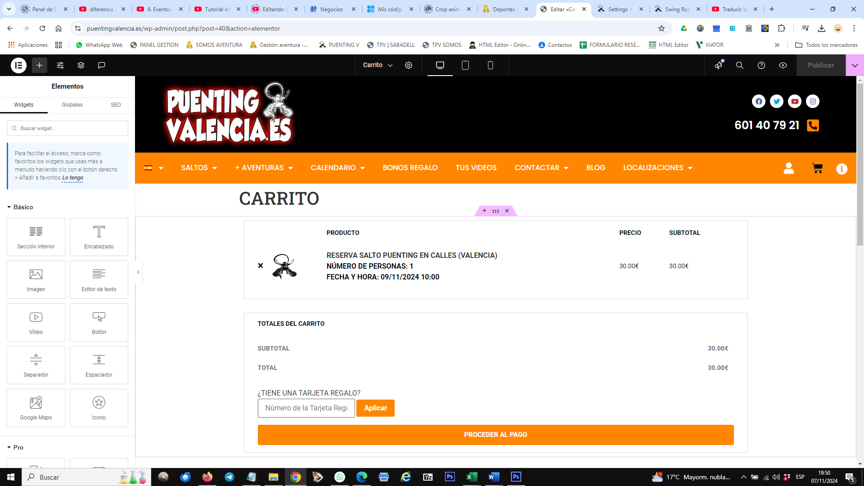

When you edit it, it shows correctly, but when you check it on website, it breaks and changes the labels as: producto by produc, price, etc. in the Spanish version. When you check at English site, it shows TOTALES DEL CARRITO and PROCEDER AL PAGO in English.

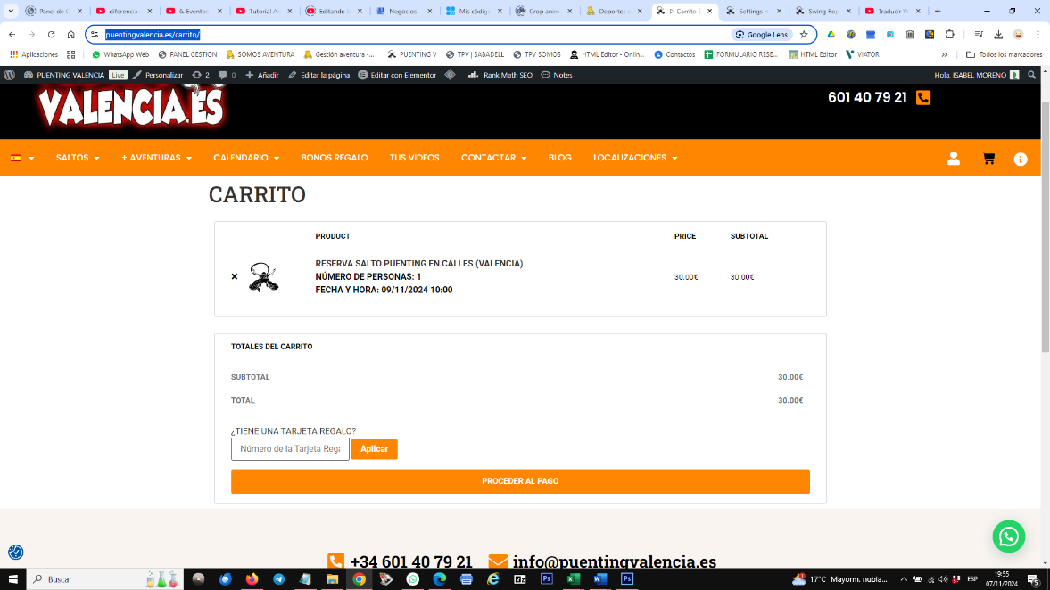<https://puentingvalencia.es/carrito/> | <https://puentingvalencia.es/en/shopping-cart/>

