When I pick this option, I get this error.I fill the fo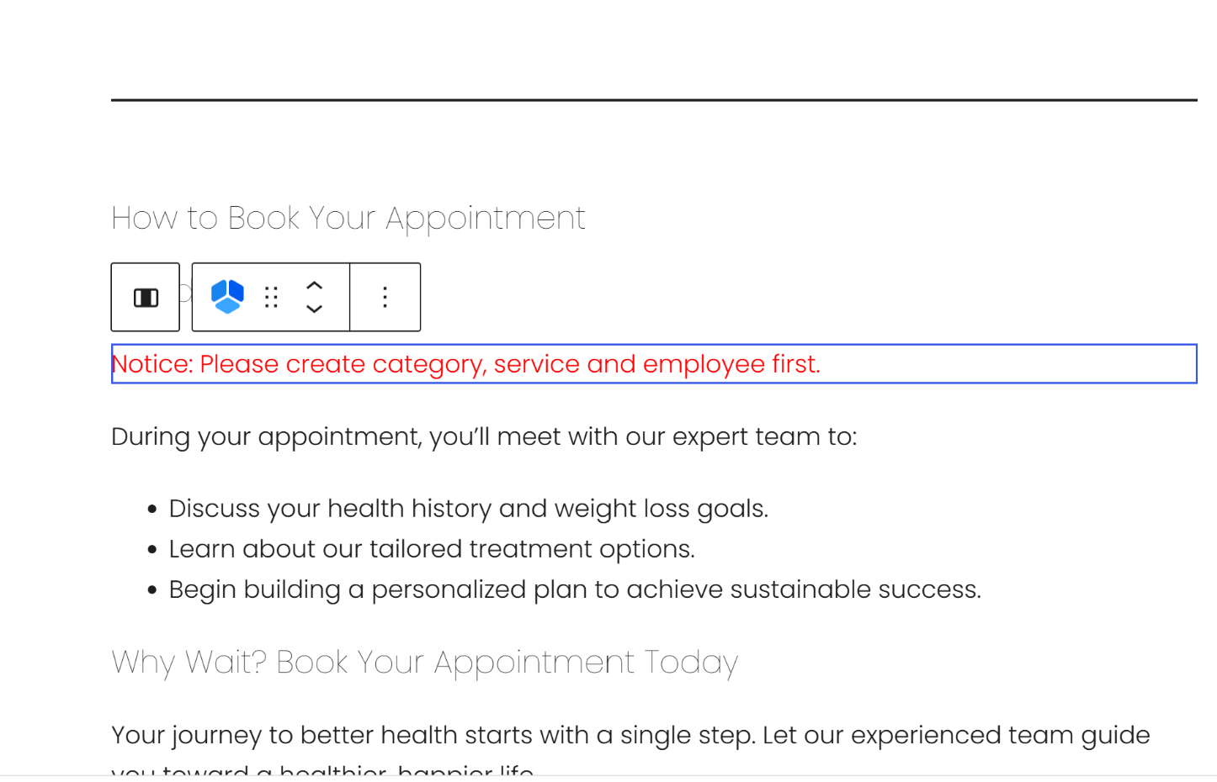

When I fill this form, customer does not get any email or message. 