DESKTOP POPUP FOR AMELIA

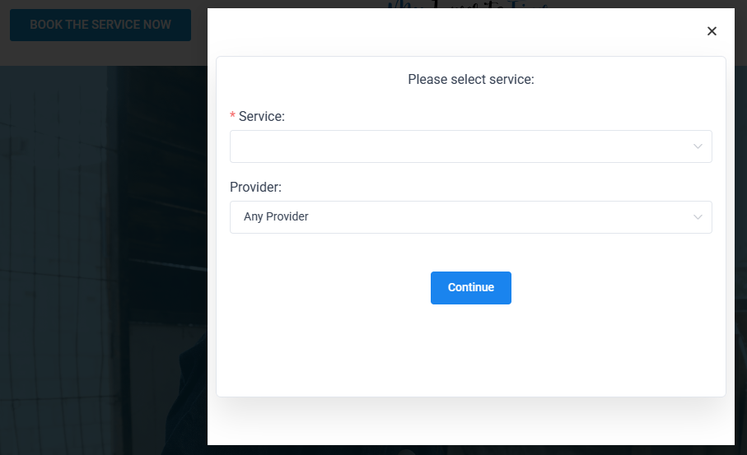

MOBILE/TABLET POPUP FOR AMELIA

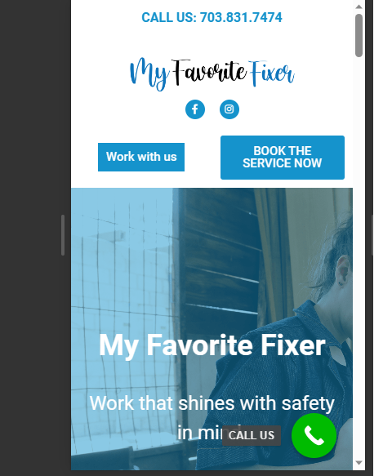

WHEN CLICKED, ONLY THE BELOW IS SHOWN WITH NO IMAGE

