**AMELIA BOOKING** This is how our “new client consultation” pulls through to Outlook Calendar:-

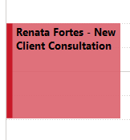

**OUTLOOK (MANUAL BOOKING MADE BY STAFF)** We would like to be able to show more detail in the body of this appointment – example of how we would like it to appear (at least if we could get their mobile number, Other Party details, how they wish to attend their appointment (zoom/telephone/in person):-

