Radio Button Issues

User Details: 1

Background: 1

# User Details:

* Author: Mariano Arias – [Mariano.arias@farmfocus.co.nz](mailto:Mariano.arias@farmfocus.co.nz)
* Date: 29/03/23
* License number is 9C8C7-EB454-9A54B-E07B4-3E3A1
* Email linked to license is [Business.Operations@Farmfocus.co.nz](mailto:Business.Operations@Farmfocus.co.nz)
* Business – Farm Focus
* Amelia Version 6.2

# Background:

1. I created an event named ATTENDED TEST (ID: 346)
2. I added myself as an attendee.
3. I can see that I have been approved to attend the event – This is seen by the GREEN RADIO BUTTON
4. I received an automatic email saying that I have been booked.

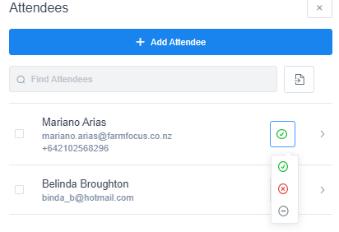

1. I then DECLINED Mariano Arias. This is done successfully – Yet I DO NOT receive an email notification saying that I have been declined.

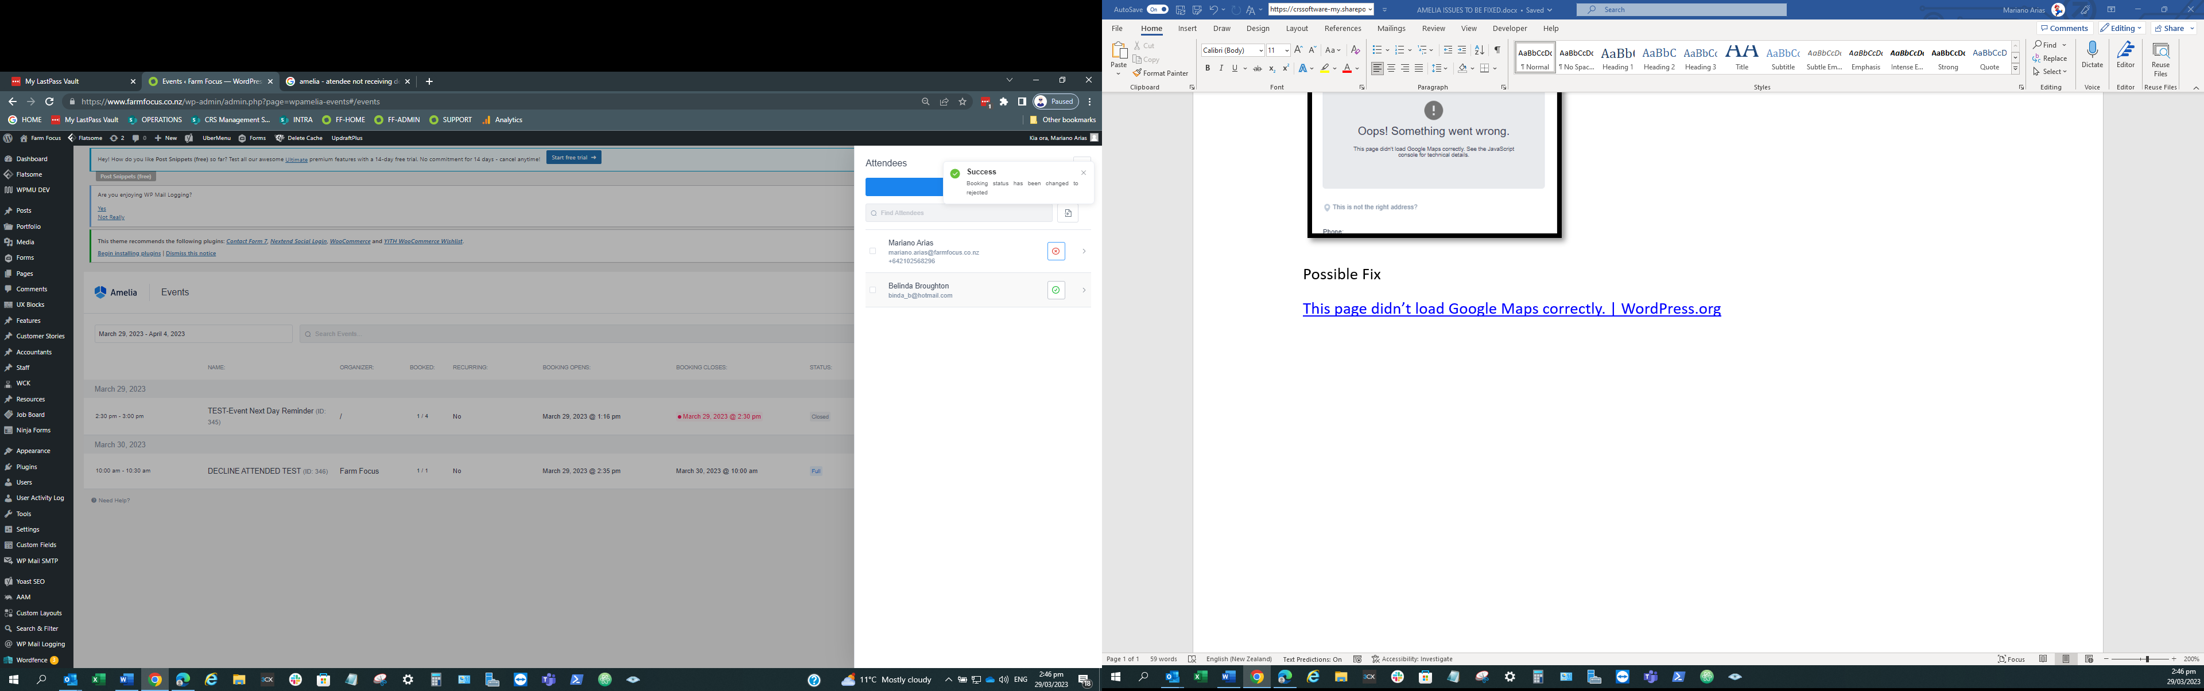

1. Yet, if I change my status back to APPROVED, I do receive an email notification saying that I have been booked.

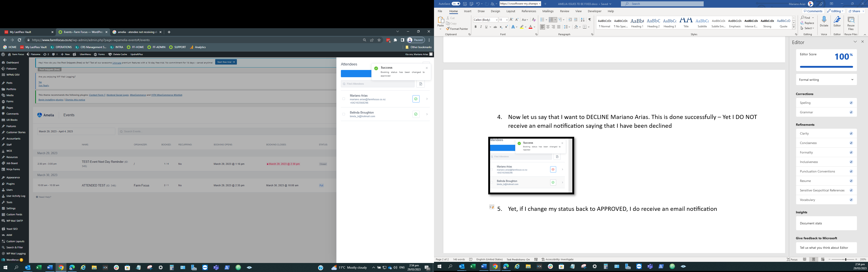

## Required Fix

What we need to happen is as follows:

When an attendee which is currently booked is DECLINED by pressing the red radio button, we want an email notification to be sent to the attendee stating that his/her attendance is been declined.

This is not happening.

