New Style- Clumpy design, background different to our own website, cannot make It so the services rest on the background, 2 services across which are huge and clumpy and not elegent at all.
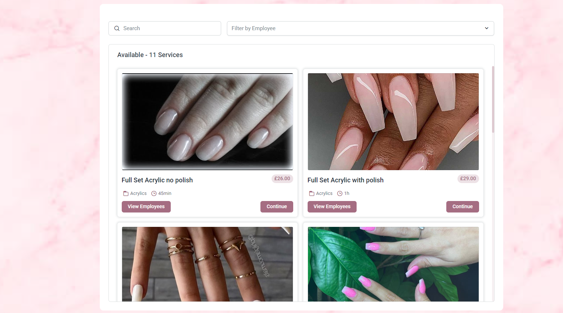

Old Style – Sleek design, background perfectly blended to our own website, 3 services across, small and elegent
