Hi Miloš!
Sorry, my slow answer!
I created a table “ONE” using SQL
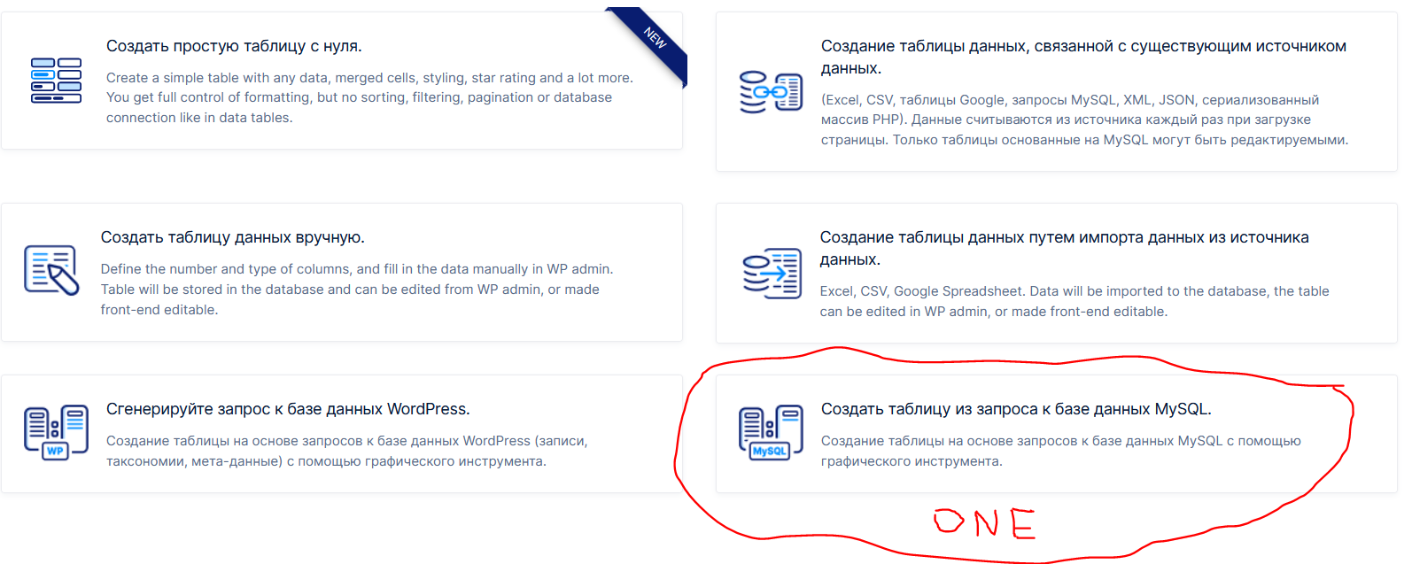
The global search works great in this table!
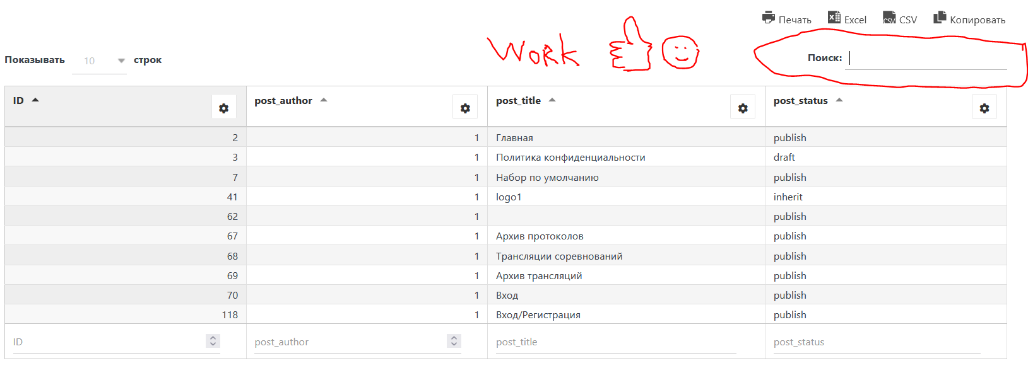
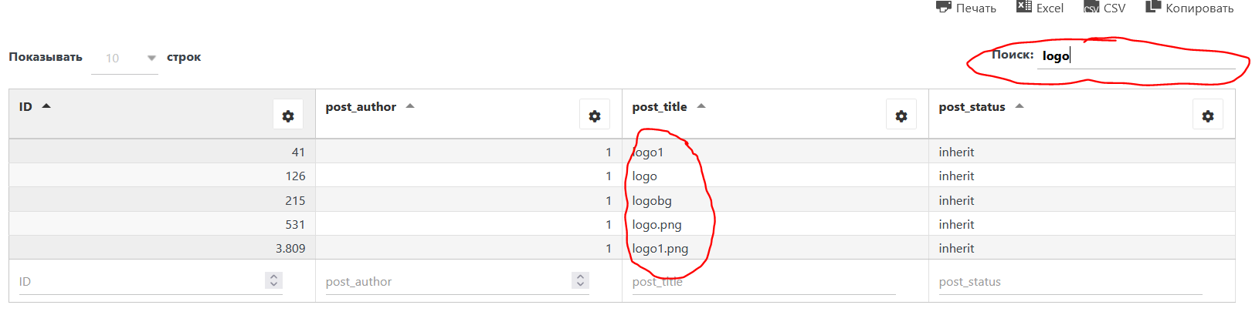
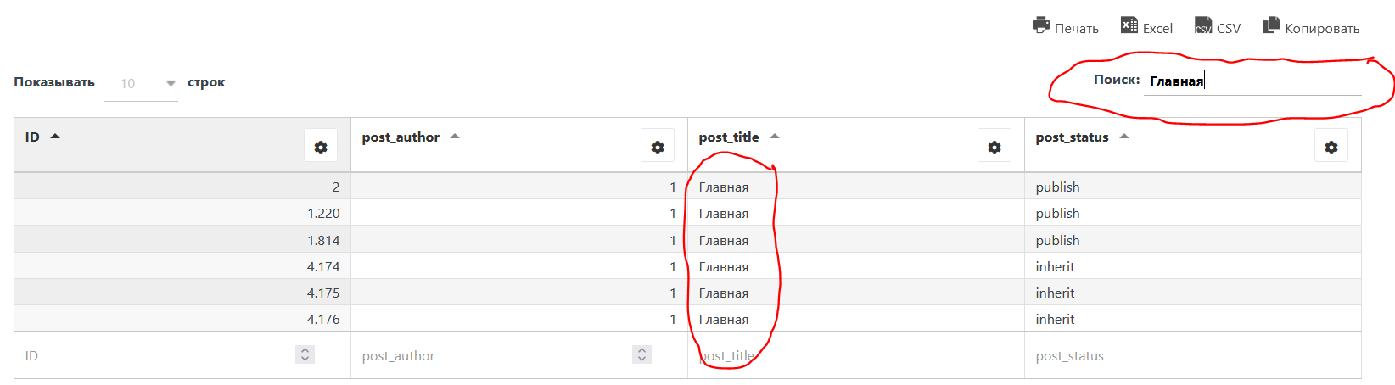
BUT! I created a table “TWO” using a request to a WordPress base and a global search does not work.
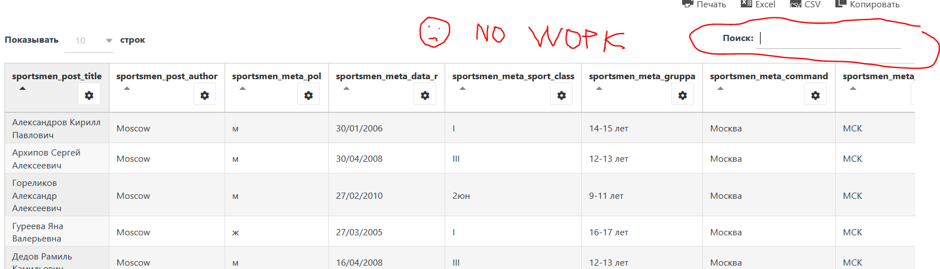
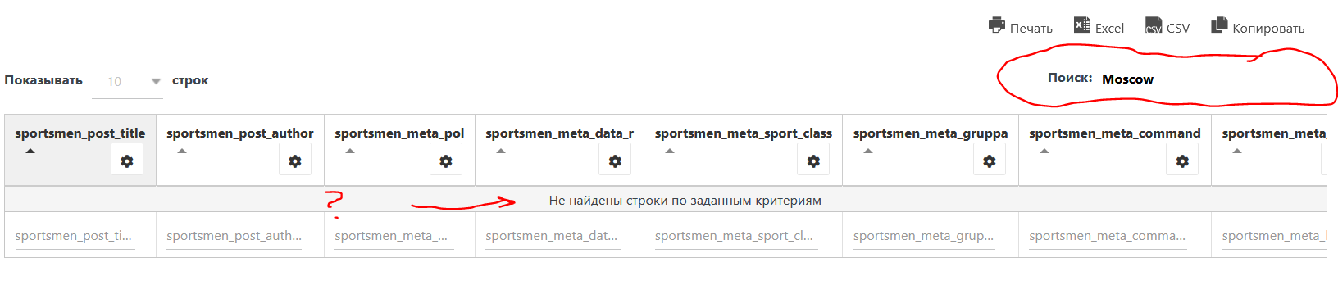
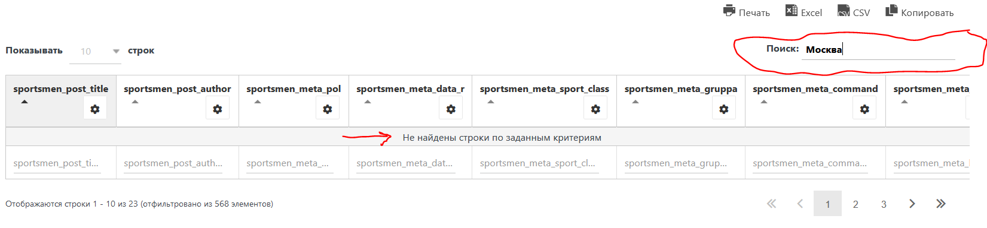
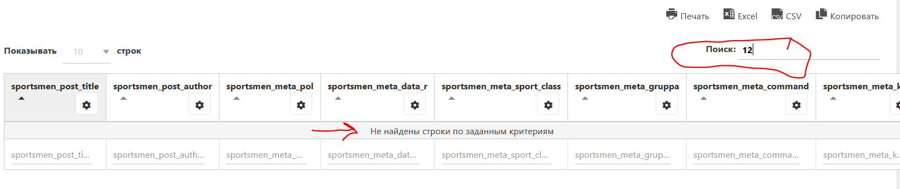
Is it possible to fix it?
Thanks!

