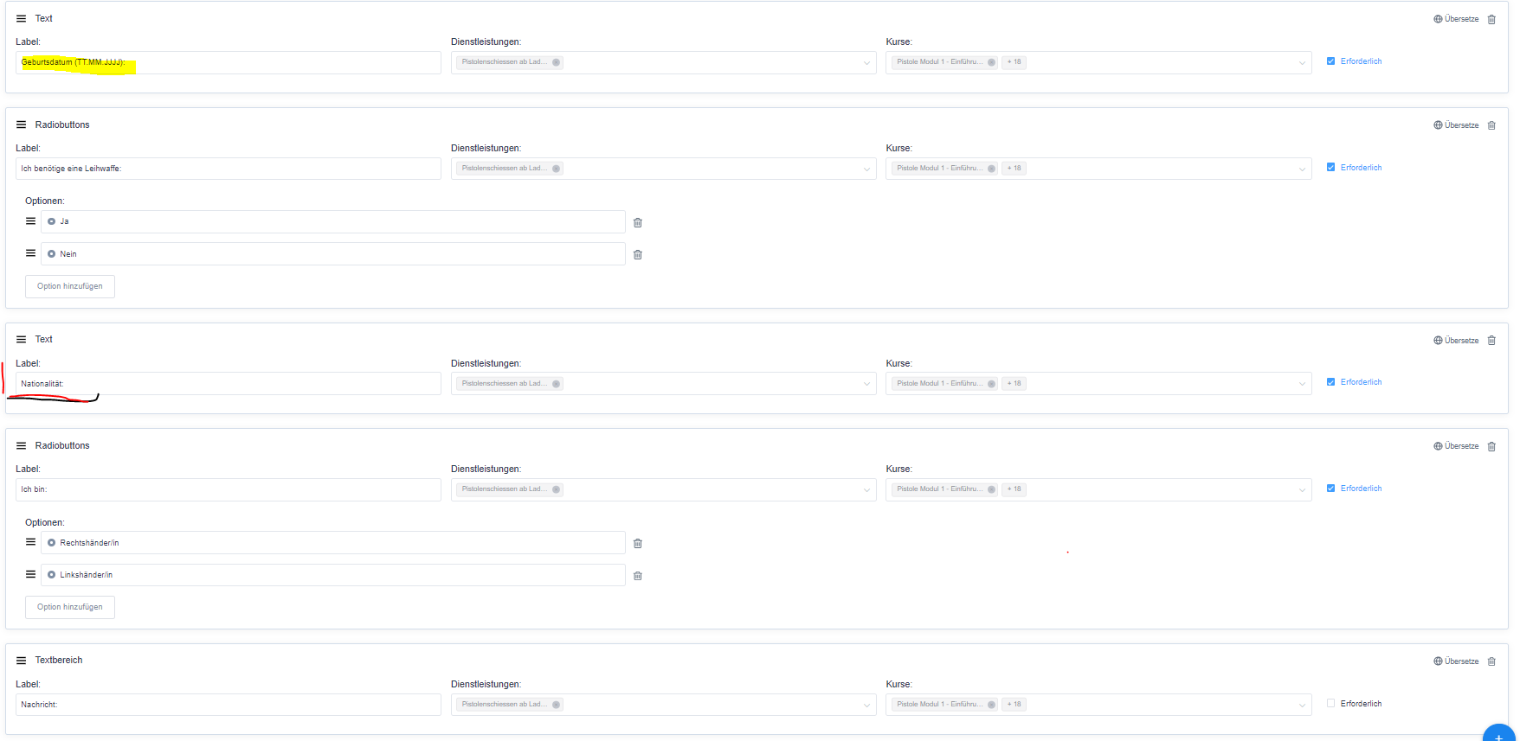
Maybe some history infos.
The custom field Geburtsdatum (TT.MM.JJJJ) I created as the first one.
The others came later. The custom field Nationalität came as the latest.

