backend

Initial calendar
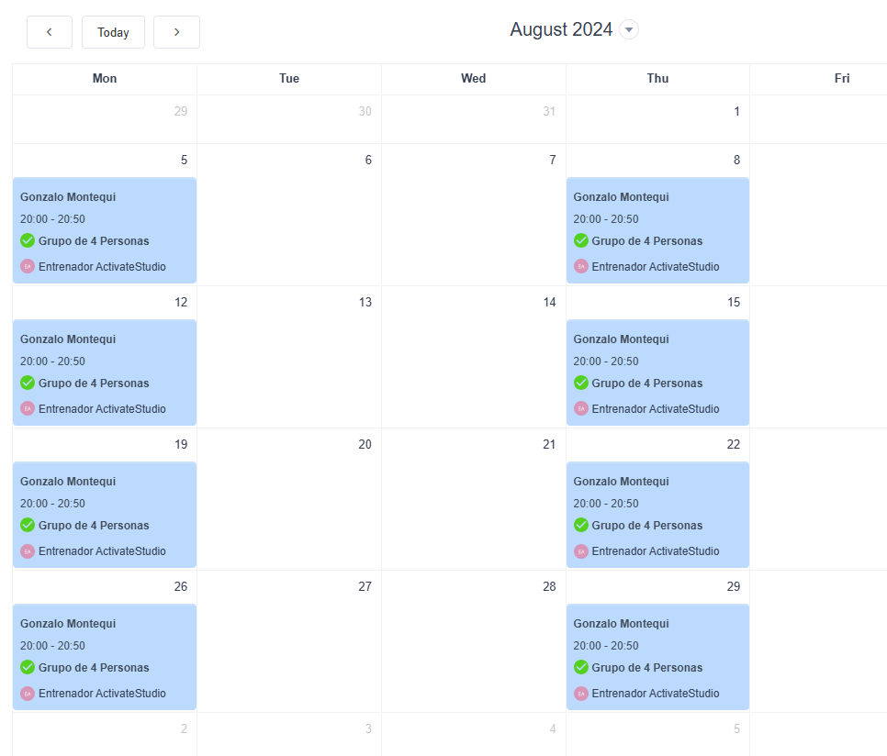

Limits:
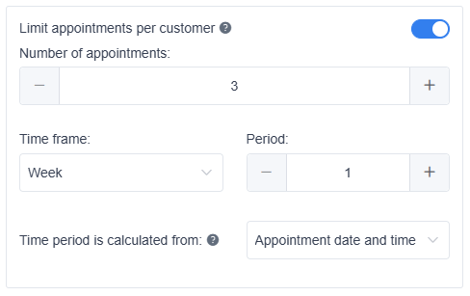
3 sessions every 7 days from the date of the appoinment.

Frontend

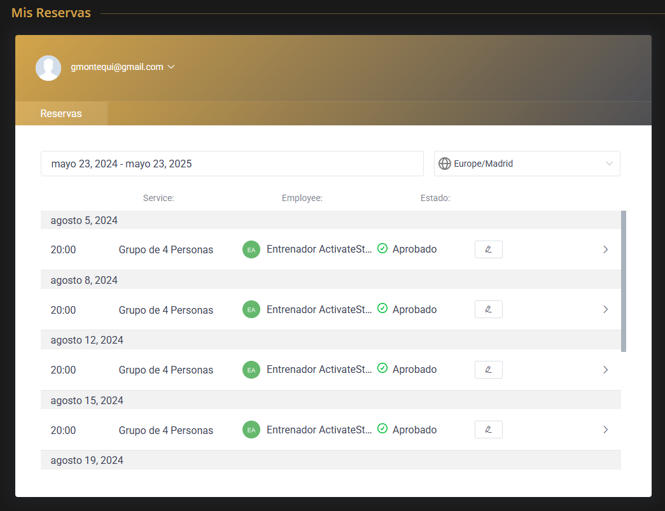
Try to change the appoinment of 5 August to, for example, 13 August
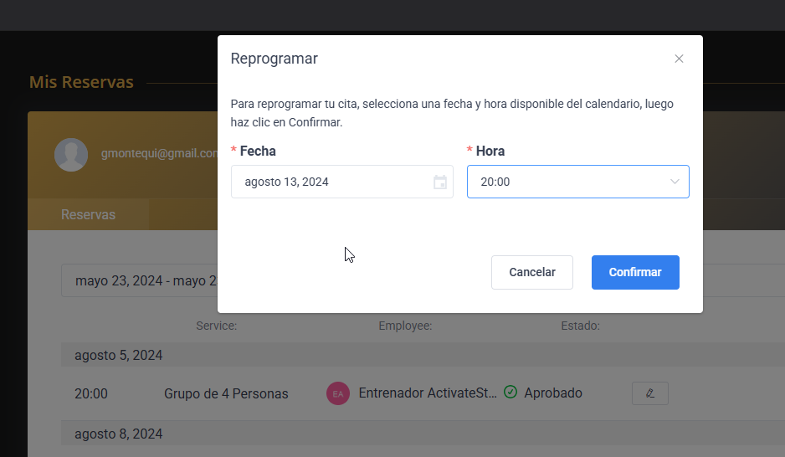
Error
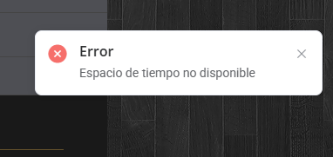

As far as I understand, the system should check that from the day of the appoinment to 7 days later (1 week) , there are no more than 3 appoinments.
If so, it should check that from August 13th (new appoinment day) to 7 days later (August 20th) there are no 3 appointments.
If you look at the calendar, I would have the appointment of the 13th, the 15th and the 19th. 3 appointments that should be allowed by the limit that I have configured. But it gives error.
Why? You can try it directly in our productive environment. We give you the permission for whatever you need.
Within the 7 days (week), do weekends count as well?

